Standards and Quality Report for Parents/ Carers
Session 2017-2018
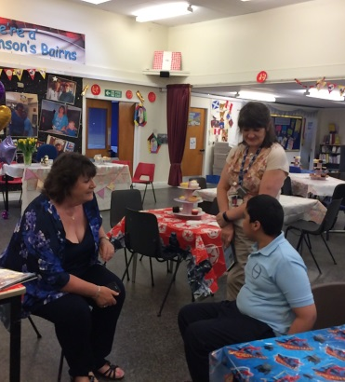
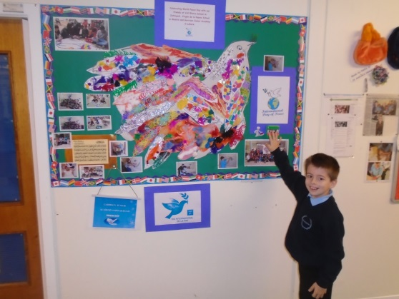
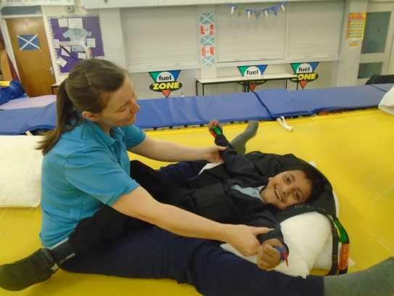
The summary report is provided for parents/carers and partners to outline our achievements this session and our priorities for next session. Throughout this session we have taken forward our priorities as detailed in our school improvement plan. Through our process of self-evaluation, we have identified how we can improve outcomes for our children and young people.

Almost all children are happy coming to school and remain so throughout the day.
Almost all children seem confident in school and have built strong relationships with key adults and most children are comfortable in the company of less familiar adults. Individual young people who have demonstrated distressed behaviour which could present as self –injurious or physically challenging have made significant improvements in their Health and Wellbeing (staff training on Trauma and Attachment, nurture principals and refresher training on appropriate pedagogy and curriculum methods for children with complex learning needs has helped this.)
Questionnaires and comments from parents/carers continue to reflect a positive school ethos in which they feel welcome and happy with their children’s progress.
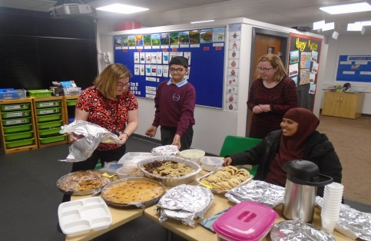
Parental engagement has been a focus of our school improvement plan this session. We have increased the number of parents visiting the school through International Education initiatives and piloted a very successful parent support group with the organisation ‘Mellow Parenting’. Parents have also taken part in massage training.

Our International education programme continues to increase the number of skilled volunteers working in our school. We continue to link with the Glasgow Bridges Project and other local partners such as Martec, Spirit Aid, Market traders and several pubs in the local area. Martec continue to be our biggest financial supporters and Martin and Christine (owners) support school by attending and participating in several events throughout the year.

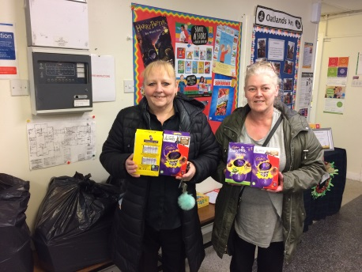
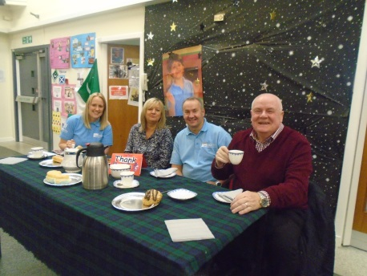
We have extended our partners this session to include Refuweegee, The Co-op, Tesco and Waukesha Bearings. These links have created a diverse staff group and richer curricular experiences for the children. Volunteers not only support the children in class but also help make resources and support events.
Almost all staff undertake regular training around Glasgow’s Nurture Principles, Augmentative and Alternative Communication (AAC), de-escalation and ethical use of physical intervention and moving and handling training to ensure children’s health and emotional wellbeing is a priority and is well supported in school.
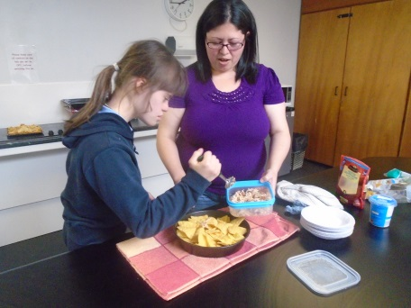
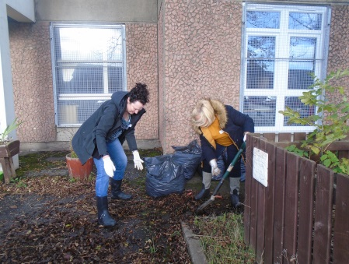
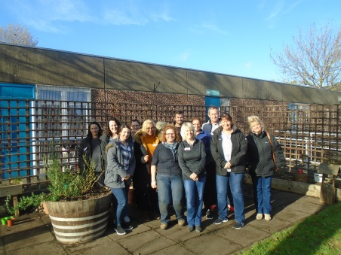
This session as part of our school improvement plan we are on the journey to becoming a Rights Respecting School.
The school encourage an open door policy and provide parents with a parent’s room and catering facilities. The school have a parent council who support the school with fundraising and play and active role in decision making. This session the parent council have been involved in city wide discussions about improving outcomes for children and young people with complex learning needs.
Twitter has allowed parents to see daily what is happening in the school and reached parents who find it hard to come into school. We have increased the number of parents and friends engaging with twitter this session. @Hampden_School
Many visitors to the school make regular comments about the welcoming atmosphere they receive.
Some new parents have commented on how beneficial school support in their own home has been – Lewis continues to provide this for new P1 parents supported by Fiona Falsey SLT. Lewis is also trained as a Mellow Ability Worker.
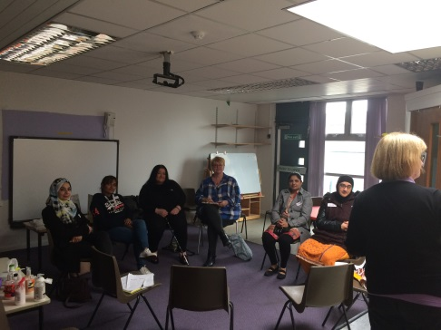
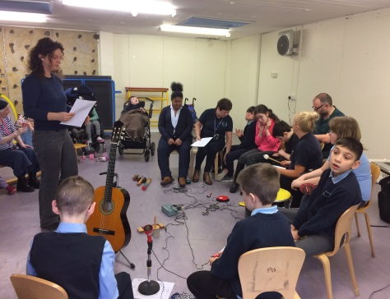
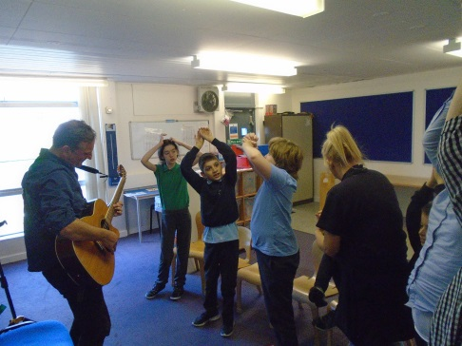
Regular mentor meetings with teaching staff ensure professional dialogue about children’s wellbeing, learning and progress. School improvement continues to be a feature on parent council agenda (HT report).
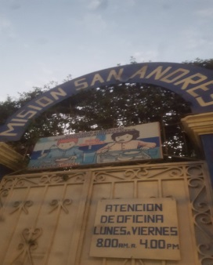
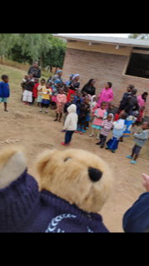
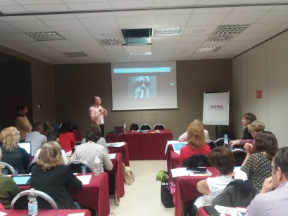
Allan Wallace (DHT) was asked to be keynote speaker at an International Education conference in Rome, following our British Council E-Twinning award.
Class teacher, Lyn Shinie visited a school in Barcelona to share good practice re: International Education and Additional Support Needs. Lyn also used part of her holiday to visit the orphanage we support in Peru to offer continued support and assistance. School staff did various fundraising events such as selling tablet to pay for Lyn’s flights.
SfLW’s taking forward sensory resources ideas after Hirstwood training and coaching
Peer observations continue to be built into quality assurance calendar to help share standards and good practice among staff.
Increased communication systems in school to ensure all staff are kept informed of current initiatives.
Fortnightly meetings with 9am staff and increased team meetings for class groups to ensure staff are updated on progress of school priorities and current developments both at school, local and national level.
All staff and most parents involved in evaluating best use of our Pupil Equity Funding linked to improvement agenda.
School nurse meeting with Health and Wellbeing workers and Head Teacher to ensure vital information/ training shared about children’s medical needs.
Rebound therapy has continued on a weekly basis (led by Physiotherapist Katrina McGurk) using our new therapy trampoline in school.
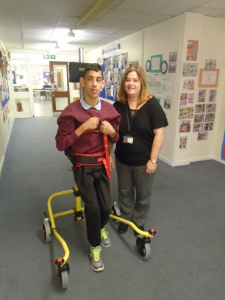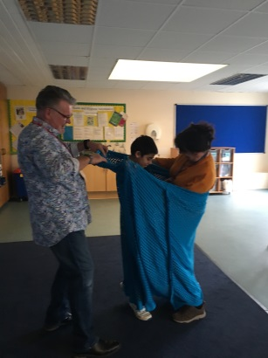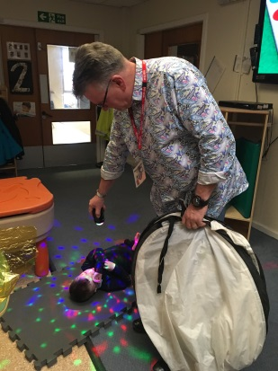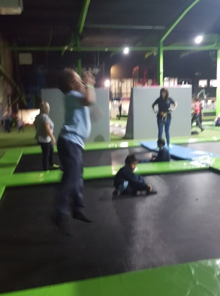
CLN head teacher working group looking at curriculum, pedagogy and methodology within Scottish context and using current research from rest of UK to inform better practice in own schools and across Glasgow – extended to include Head Teachers from other authorities.
CLN strategic working group produced paper on ‘shaping the future for children with ASN’
British Council E-twinning award 2017-2018
Glasgow City Council Excellence in International education Award 2016
British Council – Intermediary Award in International Education 2016
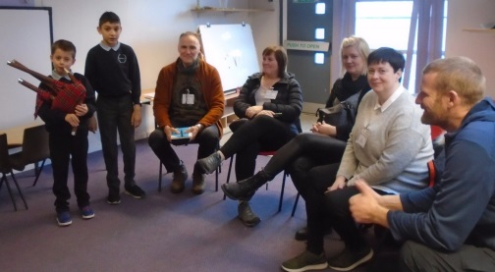
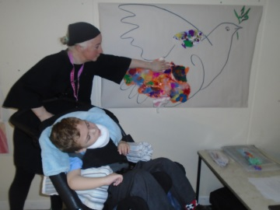
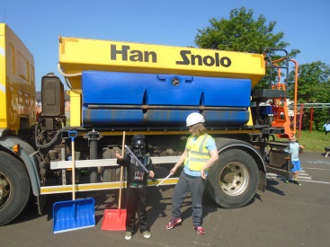
Teacher Lewis Short – Intensive Interaction Practitioner of the Year 2016-2017 (Scotland)

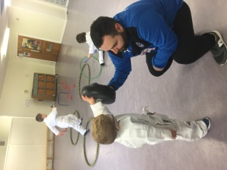
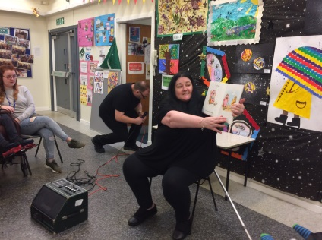
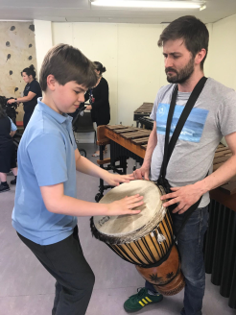
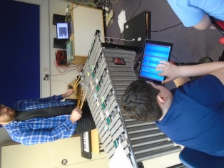

Session 2018/2019
We plan to improve: Continue our journey to becoming a Rights Respecting School and looking at Health and Wellbeing programmes and recording. Continue International Education with a focus on digital literacy and the use of Milestones in assessment, planning and tracking.

